Frontend Development with React.js

Project Documentation Format

InsightStream: Navigate the News Landscape

1.Introduction:

Project Title: InsightStream: Navigate the News Landscape

Team ID : NM2025TMID39057

Team Leader:

Name: L. Preethi

Mail id: 24bsccs08@cttewc.edu.in

Team Members:

Name: T. Kaliswari

Mail id: 24bsccs02@cttewc.edu.in

Name: D. Sandhiya

Mail id: 24bsccs04@cttewc.edu.in

Name: A.H. Lincy

Mail id: 24bsccs28@cttewc.edu.in

2.Project Overview :

•Purpose: Insight stream is a web application that helps users explore and enage with the latest news.

It provides a simple, interactive interface for browsing articles, filtering by categories,and accessing trending topics.

•Features:

News Aggregation – fetch news articles from APIs/sources.

Search and filter – Find articles by category, keyword or date.

Dashboard – User-friendly layout with categorized news.

User Authentication – Register/login with JWT protection.

3. Architecture :

•Frontend:

React.js for building dynamic and interactive user interfaces.

Bootstrap and material UI for responsive design,consistent styling, and pre-built UI components.

•Backend:

Node.js & Express.js to manage server-side logic,API endpoints, and middleware.

Handles news aggregation, filtering, search and user interactions such as saved articles or preferences.

•Database:

MONGODB STORES:

• User profiles and preferences (e.g., categories followed, saved articles).

•Real-time interactions such as likes, shares and discussion.

•News articles metadata(title, summarise, sources, timestamps).

4. Setup Instructions

Prerequisites:

Node.js (v18 or higher)

Npm or yarn

•Installation steps:

1.Clone the Repository:

cd insightstream-news-app

2.Install Dependencies:

Text

npm install

3.Create .env file (for API keys or environment variables):

REACT_APP_NEWS_API_KEY=your_api_key_here

4.Run the Application:

npm start

5. Folder Structure:

/src

/components

Header.js

NewsList.js

NewsCard.js

NewsDetails.js

Footer.js

/pages

Home.js

Categories.js

Bookmarks.js

/assets

- images

- icons

- styles

/utils

Api.js

Helpers.js

Constants.js

App.js

Index.js

6. Running the Application : 1.Frontend:

Cd client

npm start.

•This will start the react development server.

•By default,it runs on

<http://localhost:3000>.

2.Backend:

Cd server

npm start

• This will start the backend server for handling APIs and the base connections.

7.API Documention:

•User:

POST/api/user/register

Register a new user with required credentials and profile information.

POST/api/user/login

Authenticates a user and provides an access token for secured requests.

•Projects:

POST/api/projects/create

Creates a new project

(E.g.,news analysis task, research project).

GET/api/project/:id

Retrieves project details by ID.

•Applications:

POST/api/apply

Submits an application to join or contribute to a project.

•Chats:

POST/api/chat/send

Sends a chat message between users.

GET/api/chat/:user ID

Retrieves chat history with a specific user.

8. Authentication:

•JWT-based authentication for secure login.

•Middleware ensures protected routes are only accessible by logged-in users.

9.User Interface :

• Landing page – Welcome and news highlights.

• News Dashboard – Category- based browsing.

• Article Details Page – Full content with comments.

• Admin Panel – Manage categories and moderate news.

•User Profile – Saved articles & activity.

10.Testing:

• Manual testing performed at each milestone.

• Tools Used:

1.

2.

11.Screenshots or demo:

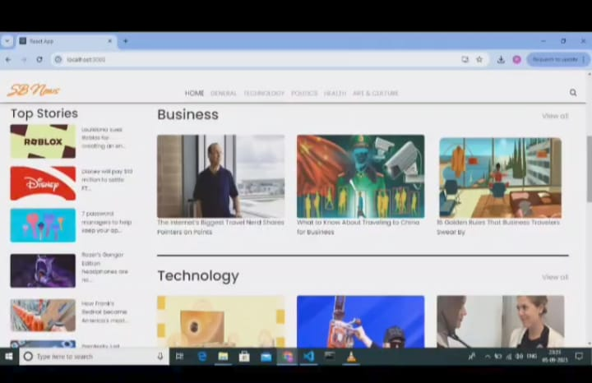

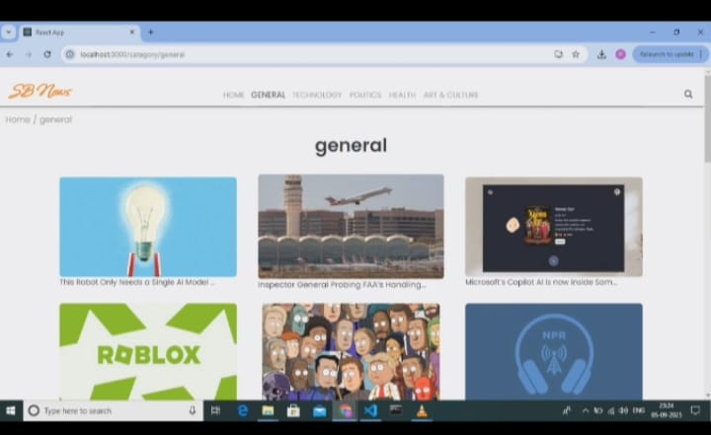

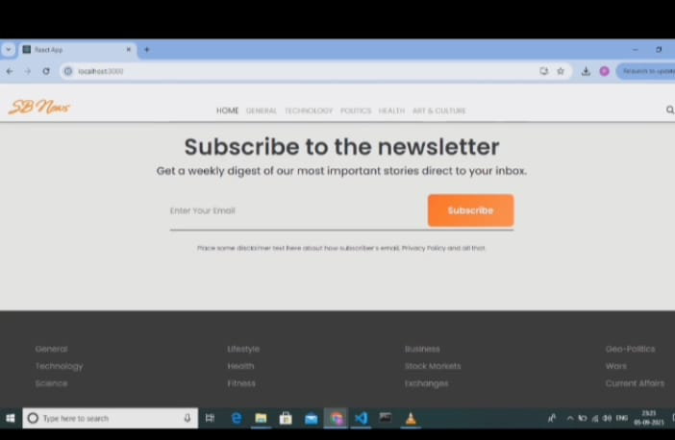

https://drive.google.com/file/d/1HCaSxTvcYkVUesGHp2qhbNfbc2tUMkGv/view?usp=drivesdk

12. Known Issues:

• API rate limiting if using free news sources.

• Comments features requires moderation improvements.

• Some mobile views need additional optimization.

13. Future Enhancements:

• Bookmark articles for later reading

• Push notification for breaking news.

• Multi-language news feed.

• AI-powered recommendations.

• Analytics for treading categories.